Table of Contents
How to make it Works 1
1. Configure ActiveMQ queues and routes 1
2. Start the Server 1
3. Start the Client 2
4. ActiveMQ Console 2
5. From Client to Resolver SV1 Request Queue - REQ.SV1 : 4
6. Resolver SV1 : 5
7. Request.sh in detail : 6
8. Result after Request.sh execution 8
9. From HOST to SV1 Response Queue - RES.SV1.C1: 8
10. How Timeout works : 8
11. Timeout some messages in REQ.SV1.TIMEOUT_1: 9
12. Response messages : 11

How to make it Works

Configure ActiveMQ queues and routes
Define the needed queues an routes in ActiveMQ broker for every client and resolver.
Restart ActiveMQ

Start the Server
- Configure Server clients :
./apl/server/config/server_properties.xml
Example :
<clientId>
<ip>192.168.153.3</ip>
<maxConnections>2</maxConnections>
<inputQueue>CLIENT.192.168.153.3.IN</inputQueue>
<outputQueue>CLIENT.192.168.153.3.OUT</outputQueue>
</clientId>
- Configure Broker properties :
./apl/server/config/server_properties.xml

- Start the server :
[javier@sagitta server]$ pwd
/home/javier/apl/server
[javier@sagitta server]$ ./server.sh &
- Two server threads are executed per Client connection.
  - More than one socket from the same remote client IP are allowed, but inputQueue, and outputQueue are shared.
  - One thread to attend input messages that will be written to client inputQueue (WrokProducer)
  - Another one to attend outgoing messages that has been written to client outputQueue (WorkConsumer).
  - WorkConsumer filters messages by source client IP and PORT, to send messages to the right destination.

Start the Client
- Configure client properties :
./apl/client/config/client_properties_1.xml
Example :
<ClientProperties>
<ServerConnection>
<host>192.168.153.3</host>
<port>5555</port>
<maxBuffer>4096</maxBuffer>
</ServerConnection>
<maxInnerQueueLength>4096</maxInnerQueueLength>
<clientName>test-client-01</clientName>
</ClientProperties>

- Start the Client :
[javier@sagitta client]$ pwd
/home/javier/apl/client
[javier@sagitta client]$ ./client_1.sh
Starting Client threads.number : 5 messages.number : 100

Sending 100 messages of type text & 100 messages of type binary ...
Type end to finish sending messages ..

Sending 100 messages of type text & 100 messages of type binary ...
Type end to finish sending messages ..

- Note : do not close the client until responses has been received

ActiveMQ Console

Queues Status :
Name Number Of Number Messages Messages
Pending Msg Of Consumers Enqueued Dequeued

CLIENT.127.0.0.1.IN 0 1 0 0
CLIENT.192.168.153.3.IN 0 1 400 400
CLIENT.192.168.153.3.OUT 0 1 0 0
REQ.DISPATCHER 0 1 400 400
REQ.SV1 0 1 200 200
REQ.SV1.C1 100 0 100 0
REQ.SV1.C2 100 0 100 0
REQ.SV1.TIMEOUT 0 1 0 0
REQ.SV2 200 0 200 0

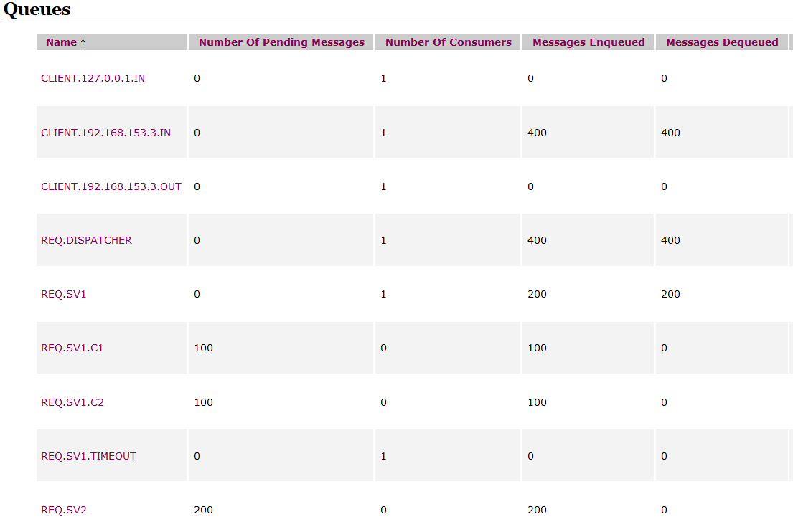
Message Example :
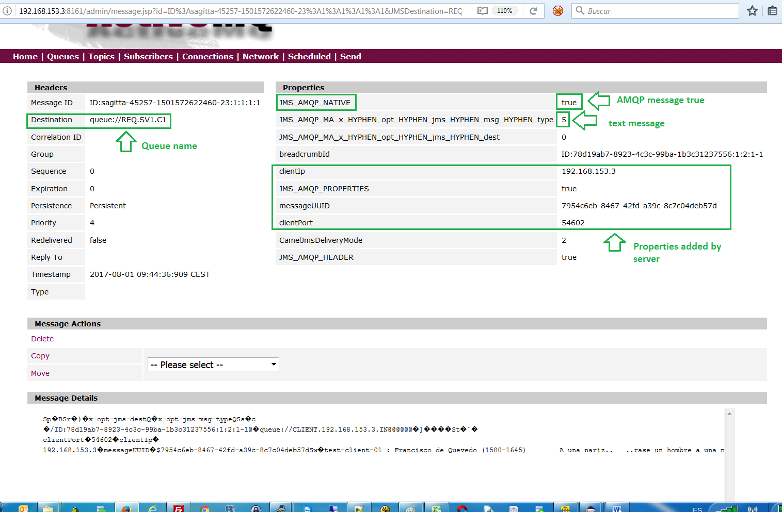

From Client to Resolver SV1 Request Queue - REQ.SV1 :

- Client Layer :
400 messages has been sent by the client and received by the server in CLIENT.192.168.153.3.IN (input queue for that client)
- Server Layer :
Server knows about the queue to use because queues per client are defined in server_properties.xml
- Broker Level :
All the received messages from all the clients has been moved to the REQ.DISPATCHER by Camel routes
<route>
<from uri="activemq:queue:CLIENT.127.0.0.1.IN"/>
<to uri="activemq:queue:REQ.DISPATCHER"/>
</route>
<route>
<from uri="activemq:queue:CLIENT.192.168.153.3.IN"/>
<to uri="activemq:queue:REQ.DISPATCHER"/>
</route>
- Broker Level :
Messages in REQ.DISPATCHER has been moved to by a loadbalance Camel route:
<route>
<!-- Broker Layer - Dispatcher to Resolver's Queues

REQ.DISPATCHER : input queue for dispatching request
REQ.SV1 : request input queue for Resolver Node1
REQ.SV2 : request input queue for Resolver Node2
REQ.SV3 : request input queue for Resolver Node3
-->
<from uri="activemq:queue:REQ.DISPATCHER"/>
<loadBalance>
<roundRobin/>
<to uri="activemq:queue:REQ.SV1"/>
<to uri="activemq:queue:REQ.SV2"/>
<!-- <to uri="activemq:queue:REQ.SV3"/> -->
</loadBalance>
</route>
- Broker Level :
Every REQ.SVk queue is the Request Queue attached to a kth Resolver node.

Resolver SV1 :

- Broker Level :
Messages received in REQ.SV1 has been dequeued and moved to by a loadbalance Camel route:
<route>
<from uri="activemq:queue:REQ.SV1"/>
<loadBalance>
<roundRobin/>
<to uri="activemq:queue:REQ.SV1.C1"/>
<to uri="activemq:queue:REQ.SV1.C2"/>
<!-- <to uri="activemq:queue:REQ.SV1.C3"/> -->
</loadBalance>
</route>
- Resolver Level :
There is a server process to attend every REQ.SV1.Ck queue ( 1 per Ckth queue ) .
[javier@sagitta cob4brk]$ pwd
/home/javier/apl/cob4amqp/cob4brk
[javier@sagitta cob4brk]$ cat request.sh
#!/bin/bash
#
# Program chaining :
#
# request (main) --> driver.o (driver.cob) --> req_trx.so (req_trx.cob)
#
cat /dev/null > request_1.log
#
./request db_connection.xml broker_connection.xml request_1.xml 1>>request_1.$PPID.log 2>>request_1.$PPID.log
This process knows about the Ck queue by a config file ( request_1.xml ) :
[javier@sagitta cob4brk]$ cat ../resources/request_1.xml
<?xml version="1.0" encoding="ISO-8859-1"?>
<Queue>
<prgname>req_trx</prgname>
<input>REQ.SV1.C1</input>
<output>REQ.SV1.HOST</output>
<error>REQ.SV1.ERROR</error>
<timeout>REQ.SV1.TIMEOUT</timeout>
</Queue>

- Resolver Level
Let start request.sh

Request.sh in detail :

Note : .pco extension has been assigned to cobol + embedded PostgreSQL files. Those files has to be precompiled with Open Cobol ESQL (Ocesql) Precompiler.
- Program Chaining : request (queueListen.cpp) --> driver.o (driver.pco) --> req_trx.so (req_trx.cob)
- queueListen.cpp: Load configuration files and connect to AMQP broker .
- driver.pco :
  - Connect to PostGreSQL DB ( in fact to the PGBouncer connection pool )
  - Load queue configuration and TRX to execute configuration file :
<?xml version="1.0" encoding="ISO-8859-1"?>
<Queue>
<prgname>req_trx</prgname>
<input>REQ.SV1.C1</input>
<output>REQ.SV1.HOST</output>
<error>REQ.SV1.ERROR</error>
<timeout>REQ.SV1.TIMEOUT</timeout>
</Queue>
  - Call TRX program (req-trx.so)
- req_trx.pco :
  - Listen for incoming messages in REQ.SV1.Ci queue
  - For every received message calculates his properties that are displayed (also the message).
  - Save the message in MESSAGES database table, and also creates a row in TIMEOUT database table.
  - Writes the message to REQ.SV1.HOST output queue and also REQ.SV1.TIMEOUT
  - Commit Changes to DB
  - Listen for next message

- Queues Status :

Name Number Of Number Messages Messages
Pending Msg Of Consumers Enqueued Dequeued

REQ.SV1.C1 0 1 100 100
REQ.SV1.C2 100 0 100 0
REQ.SV1.HOST 100 0 100 0
REQ.SV1.TIMEOUT 0 1 100 100
REQ.SV1.TIMEOUT_1 50 0 50 0
REQ.SV1.TIMEOUT_2 50 0 50 0

Messages from REQ.SV1.C1 has been consumed and written to REQ.SV1.HOST
Messages from REQ.SV1.C2 are waiting to be consumed by a new server process
Messages from REQ.SV1.TIMEOUT has been consumed by a loadbalance Camel Route :
<route>
<from uri="activemq:queue:REQ.SV1.TIMEOUT"/>
<loadBalance>
<roundRobin/>
<to uri="activemq:queue:REQ.SV1.TIMEOUT_1"/>
<to uri="activemq:queue:REQ.SV1.TIMEOUT_2"/>
<!-- <to uri="activemq:queue:REQ.SV1.TIMEOUT_3"/> -->
</loadBalance>
</route>

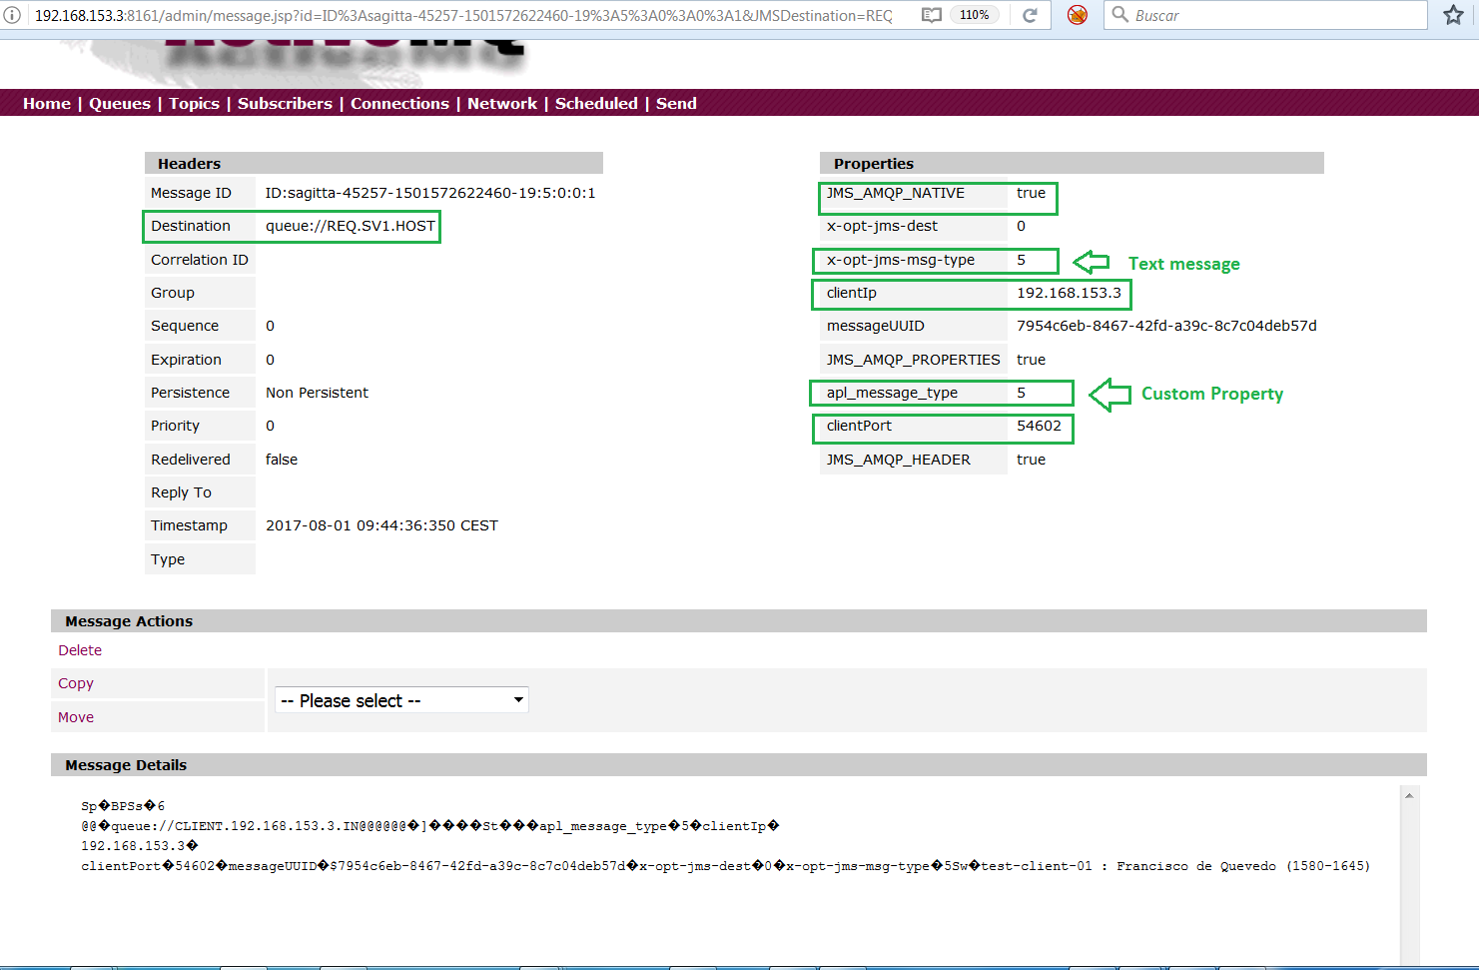

Result after Request.sh execution

- Messages has been processed from REQ.SV1.Ci to REQ.SV1.HOST and are waiting to be sent to the HOST (final Resolver)
- Database entries in MESSAGES and TIMEOUT tables has been created for every processed message.
- Messages has been created in REQ.SV1.TIMEOUT_n queue, by a Camel route

From HOST to SV1 Response Queue - RES.SV1.C1:

#[javier@sagitta server]$ pwd
/home/javier/apl/server

- This is simulated by a java process (moveMessage.sh )
$JRE/bin/java -Dbroker.config=./config/broker_properties.xml -Dinputqueue=REQ.SV1.HOST -Doutputqueue=RES.SV1.C1 -Ddelay=2000 -cp $JARFILES com.indarsoft.hps.MoveMessage
- Listen on -Dinputqueue=REQ.SV1.HOST
- Every dequeued message is delayed a random amount of time between 1000 to 1000 + delay milliseconds ( 1 to 3 seconds in case delay is 2000), to allow that some messages would be timeout (see next section)
- The message is written to RES.SV1.C1 response queue. For simplicity we have bypassed RES.SV1.HOST and move messaged directly to RES.SV1.C1.
- Note : In fact the output queue would be RES.SV1.HOST that is managed by another Camel route that load-balance message into RES.SV1.Ci queues
<route>
<from uri="activemq:queue:RES.SV1.HOST"/>
<loadBalance>
<roundRobin/>
<to uri="activemq:queue:RES.SV1.C1"/>
<to uri="activemq:queue:RES.SV1.C2"/>
<!-- <to uri="activemq:queue:RES.SV1.C3"/> -->
</loadBalance>
</route>
Every RES.SV1.Ci would be managed by a server response process ( response.sh )

How Timeout works :
#[javier@sagitta server]$ pwd
/home/javier/apl/server

- This is managed by a java process ( timeout_1.sh & timeout_2.sh)
$JRE/bin/java -Dbroker.config=broker_properties.xml -Dinputqueue=REQ.SV1.TIMEOUT_1 (or -Dinputqueue=REQ.SV1.TIMEOUT_2) -Doutputqueue=RES.SV1 -Dtimeout=2000 -Ddb.config=pgbouncer_properties.xml -cp $JARFILES com.indarsoft.hps.TimeoutMessage
Every received message schedules a timeout. When message is written to REQ.SVi.HOST is also saved to REQ.SVi.TIMEOUT .
- A timeout request is written to the TIMEOUT DB table for the messageUUID .
- When the response is received from HOST, the timeout is removed by response.sh (removes the row in TIMEOUT DB table for the messageUUID )
TimeoutMessage listen for messages REQ.SVi.TIMEOUT_i (inputqueue) , with an entry in TIMEOUT DB table :
- When the timeout is finished an attempt to delete the row from TIMEOUT is executed for the messageUUID.
- In case the delete returns 0 row , the message has been answered from the HOST and processed by response.sh, and nothing else is necessary.
- In case the delete returns 1 row , the message has NOT been answered from the HOST (which means that has been a TIMEOUT), and a TIMEOUT response is generated to RES.SVi (outputqueue)

Timeout some messages in REQ.SV1.TIMEOUT_1:

- Let’s timeout everything in queue REQ.SV1.TIMEOUT_1

Name Number Of Number Messages Messages
Pending Msg Of Consumers Enqueued Dequeued

REQ.SV1.TIMEOUT_1 50 0 50 0
REQ.SV1.TIMEOUT_2 50 0 50 0
RES.SV1 0 1 0 0

#[javier@sagitta server]$ pwd
/home/javier/apl/server
[javier@sagitta server]$ timeout_1.sh &

- Resolver Level :
Every message is consumed from REQ.SV1.TIMEOUT_1 timeout_1.sh, timeout a response y generated to RES.SV1 for the message.
Name Number Of Number Messages Messages
Pending Msg Of Consumers Enqueued Dequeued

REQ.SV1.TIMEOUT_1 0 0 50 50
REQ.SV1.TIMEOUT_2 50 0 50 0
RES.SV1 0 1 50 50

- Broker Level :
The following Camel route consumes every message from response queue in Resolver (RES.SV1), and move it to RES.DISPATCHER
<route>
<from uri="activemq:queue:RES.SV1"/>
<to uri="activemq:queue:RES.DISPATCHER"/>
</route>
A new Camel route filters the messages from RES.DISPATCHER to the correspond output queue for the server socket
<route>
<from uri="activemq:queue:RES.DISPATCHER"/>
<choice>
<when>
<simple>${header.clientIp} contains '192.168.153.3'</simple>
<to uri="activemq:queue:CLIENT.192.168.153.3.OUT"/>
</when>
<when>
<simple>${header.clientIp} contains '127.0.0.1'</simple>
<to uri="activemq:queue:CLIENT.127.0.0.1.OUT"/>
</when>
<otherwise>
<to uri="activemq:queue:RES.DISPATCHER.ERROR"/>
<stop/>
</otherwise>
</choice>
</route>

- Server Level :
Server WorkConsumer thread filters messages by source client IP and PORT from output queue, to send messages to the right destination.
Example : Received timeout messages:
[javier@sagitta received]$ pwd
/home/javier/apl/client/data/received

[javier@sagitta received]$ cat test-client-01-12488798024011.qrcv
( clientIp='192.168.153.3' ) AND ( clientPort='54602' )->message timeout - test-client-01 : Francisco de Quevedo (1580-1645) A una nariz.. ..rase un hombre a una nariz pegado,..rase una nariz superlativa,..rase una nariz say..n y escriba,..rase un peje espada muy barbado.Era un reloj de sol mal encarado,..rase una alquitara pensativa,..rase un elefante boca arriba,era Ovidio Nas..n m..s narizado...rase un espol..n de una galera,..rase una pir..mide de Egipto,las doce Tribus de narices era...rase un naric..simo infinito,much..simo nariz, nariz tan fieraque en la cara de An..s fuera delito.

Response messages :

- Resolver Level :

There is a server process to attend every RES.SV1.Ck queue ( 1 per Ckth queue ) .
Let start response.sh
[javier@sagitta cob4brk]$ pwd
/home/javier/apl/cob4amqp/cob4brk
[javier@sagitta cob4brk]$ ./response.sh &

- Server Level :

./timeout_1.sh &
./moveMessage.sh &
./timeout_2.sh &

The flow is the same described in the previous section.

- Client Level :

[javier@sagitta received]$ ls -ltra
total 300
drwxrwxr-x 4 javier javier 35 Jul 30 11:21 ..
-rw-rw-r-- 1 javier javier 11 Aug 1 00:05 do_not_delete.txt
-rw-rw-r-- 1 javier javier 586 Aug 1 18:25 test-client-01-891412316731.qrcv
-rw-rw-r-- 1 javier javier 586 Aug 1 18:25 test-client-01-891414684535.qrcv
-rw-rw-r-- 1 javier javier 586 Aug 1 18:25 test-client-02-891419662135.qrcv

[javier@sagitta received]$ cat test-client-01-892203025021.qrcv
( clientIp='192.168.153.3' ) AND ( clientPort='45528' )->message received from : REQ.SV1.HOST to : RES.SV1.C1 delayed 1979 - test-client-01 : Francisco de Quevedo (1580-1645) A una nariz.. ..rase un hombre a una nariz pegado,..rase una nariz superlativa,..rase una nariz say..n y escriba,..rase un peje espada muy barbado.Era un reloj de sol mal encarado,..rase una alquitara pensativa,..rase un elefante boca arriba,era Ovidio Nas..n m..s narizado...rase un espol..n de una galera,..rase una pir..mide de Egipto,las doce Tribus de narices era...rase un nar

